# IT666 – VPN Lab

Ryan J. Skelly – [rjs1070@wildcats.unh.edu](mailto:rjs1070@wildcats.unh.edu) – 4/14/21

Task 1: (30 points) Provide screen captures for both instances showing the security group information

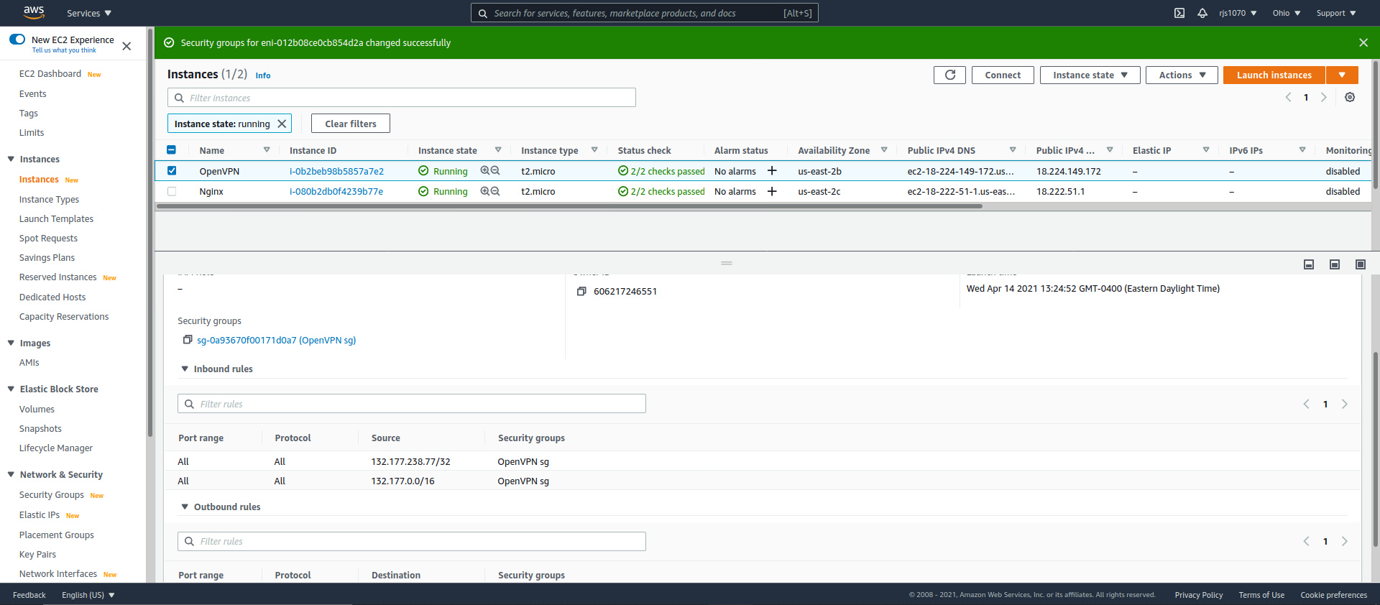

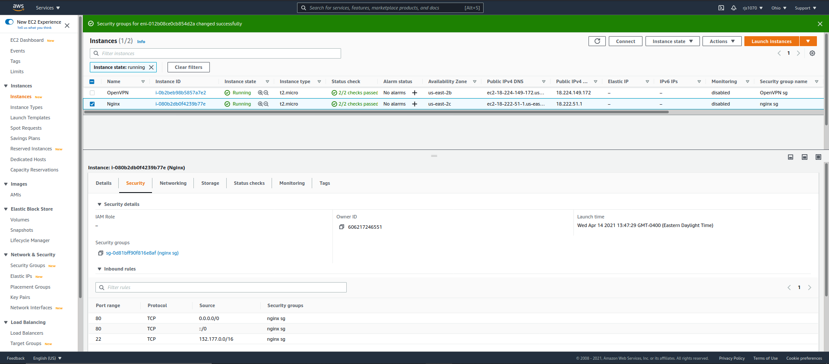

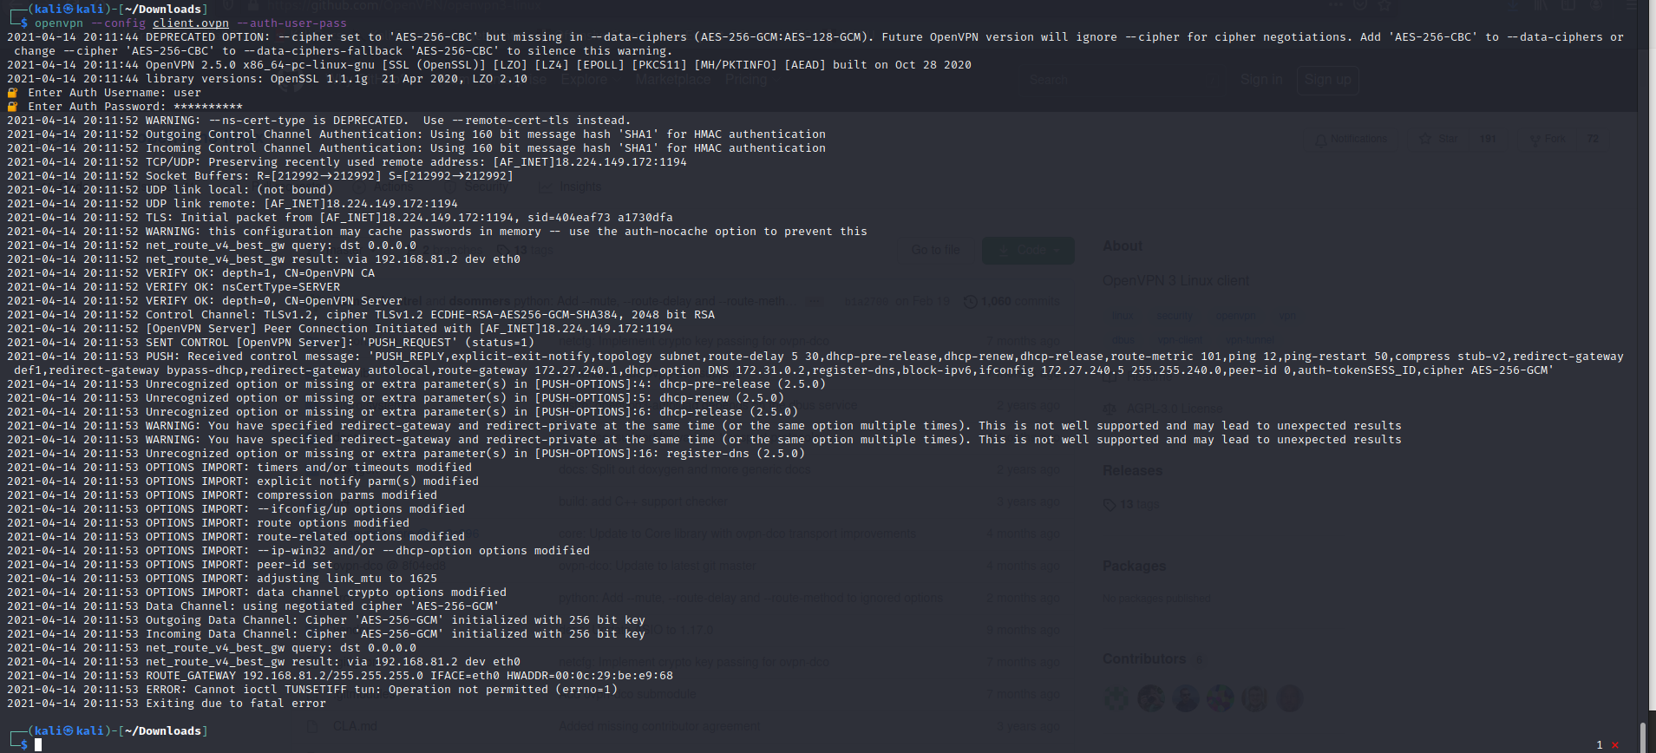For some reason I was always unable to start my openvpn instance(whether it was openvpn or openvpn3) with the client ovpn file

Task 2.1: (5 points) Provide a screen capture of a port scan for the public address of the OpenVPN server

Task 2.2: (5 points) Provide a screen capture of a port scan for the private address of the OpenVPN server

Task 2.3: (5 points) Provide a screen capture of a port scan for the public address of the Nginx server

Task 2.4: (5 points) Provide a screen capture of a port scan for the private address of the Nginx server

## Task 3: Install Nginx server

Like the OpenVPN server, in real life this would be done programmatically to allow for automated recovery and scalability. For this lab you can ssh to the instance and manually configure

ssh -i your-keypair-pem ec2-user@private-ip-address-nginx-server

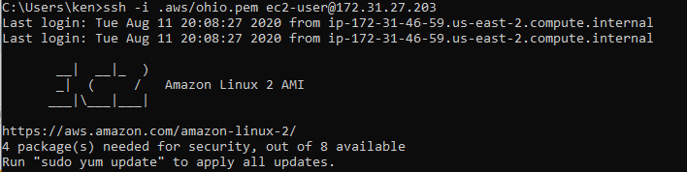

Run the following commands

sudo amazon-linux-extras install -y nginx1.12

sudo service nginx start

**Tips/Questions:**Can anyone with access to the VPN automatically have access to the Nginx server? What alternative network controls are possible? How might IAM controls be used?

Is the possible to configure the OpenVPN server without using SSH? Should your OpenVPN credentials and your SSH credentials be the same?

Task 3.1: (10 points) Provide a screen capture of a port scan for the public address of the Nginx server

Task 3.2: (10 points) Provide a screen capture of a port scan for the private address of the Nginx server

## Task 4: Security Test

Open a browser and go to the admin page of the OpenVPN access server: My case this was [https://18.130.235.167:943/admin](https://18.130.235.167:943/admin%20)  Login with user "openvpn" and the password you set earlier.

* On "User Management" page
  + "Revoke Certificate" for the user you created.

This will terminate your currently open VPN session.

Task 4.1: (10 points) Provide a screen capture of a port scan for the public address of the Nginx server

Task 4.2: (10 points) Provide a screen capture of a port scan for the private address of the Nginx server

Task 4.3: (10 points) Attempt to reconnect your VPN, provide a capture